**Level Design Assignment**

**INSTRUCTIONS:** To submit this assignment, please provide a link to the github repository along with your screenshots of the mockup to **nick@digitalscorpioninteractive.com**.

When creating your level blockout, keep the following scope in mind:

1. Key Genre: Metroidvania/2D Side Scrolling adventure
2. Provide areas for platforming, combat, moment to moment narrative gameplay, and goals to take place.
3. Keep in mind that no assets will need to be utilized - you may just blockout this level. Alternatively you may utilize kitbashing as a solution.

Tip:  Level mock-ups are generally utilized in the level design process to show your work prior to any work being done.  For 2D platformers, we recommend you utilize a side-view.

**Scope:**

* Limited to a total of 3 connecting areas that can accurately display the following:
  + Moment to moment narrative
  + Platforming
  + Combat
  + Goal
* Engine: Unity

**Step One:  Identify the games that you’ll be pulling inspiration from.**

Given the rules above, what are the three most impactful games of all time? Justify your choice for each. By what quality or qualities are impact being measured? (Minimum of 3)

* Mega Man X
* **Afterimage**
* Super Castlevania IV

**Step Two:  Expansion**

* Based on the three games chosen above, pick the game with the most interesting level design in your own opinion.
  + **Afterimage**
* Add a new hidden or optional level 1/2 to 2/3 of the way through the game.  Not a reskin of an existing level, or addition to an existing level.
* Explain the level’s context in relationship to the rest of the game.
  + Mechanically
    - The player has jump, double wall jump, crouch and slide mechanics and they typically won’t be able to get through this area without the double jump as this is their way to access the upper area of the map.
  + Narratively
    - This level is just after completing an underground area and defeating a mini boss that tells the player to get stronger so that they would be able to defeat the main boss. The player then enters a town which is their rest area which they then go into the new area (Field of Geo) to get to their next objective (finding some of the character abilities to get stronger)
* Identify the goal of the level.
  + The goal of the level was to push together all of the other player mechanics together in tandem to get to the next area of rest.
* Asset list—include existing objects used, as well as new assets required
  + Remember everything the player sees and/or interacts with is an object.
  + Recommended assets:
    - 2D Player Controller
    - Primitive Objects
* Mockup of the level—including a key/legend to identify all objects in the world - **Draw this**
  + Mockup should have a clear sense of scale, layout and object placement.
  + The mockup should be a blueprint, not merely a silhouette of layout.
  + 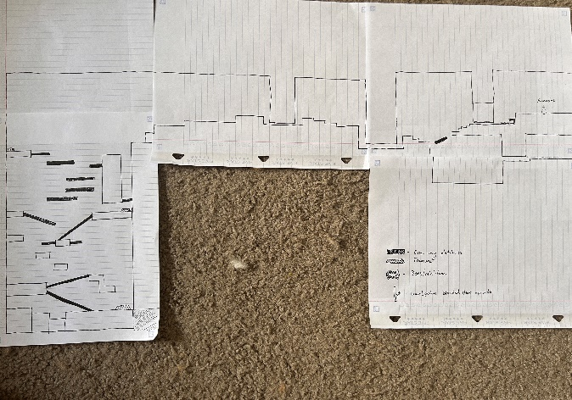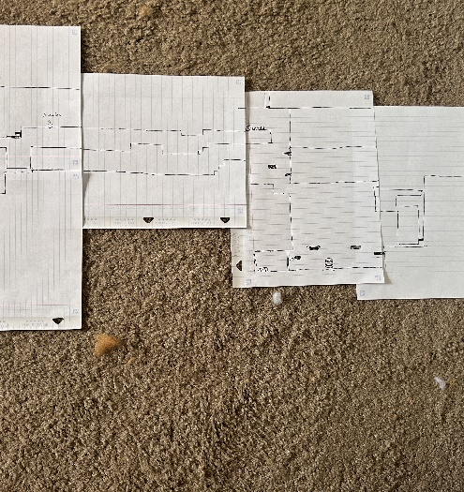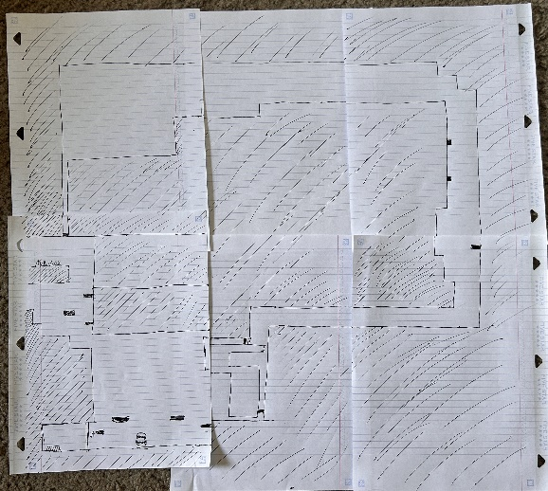These should be created by the submitter, not something sourced.
* Implementation of the level—including a key/legend to identify all objects in the world.
  + Based on your previous design work, go into Unity and block out the level you have chosen to design.